# Results Discussion

## Closed-Loop Response to a Voltage Step Input and a Disturbance Torque

Block Diagrams

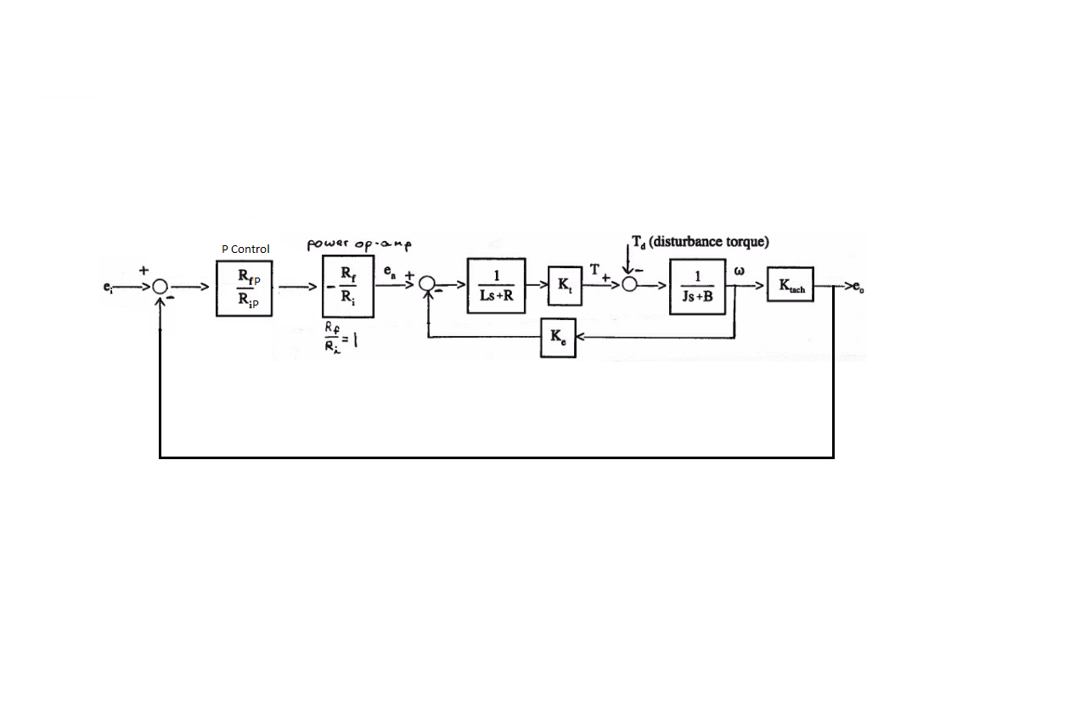

Figure #: P Controller

**Figure #, figure #, and figure #** show the closed loop system block diagrams for the P, I, and PI controllers respectively.

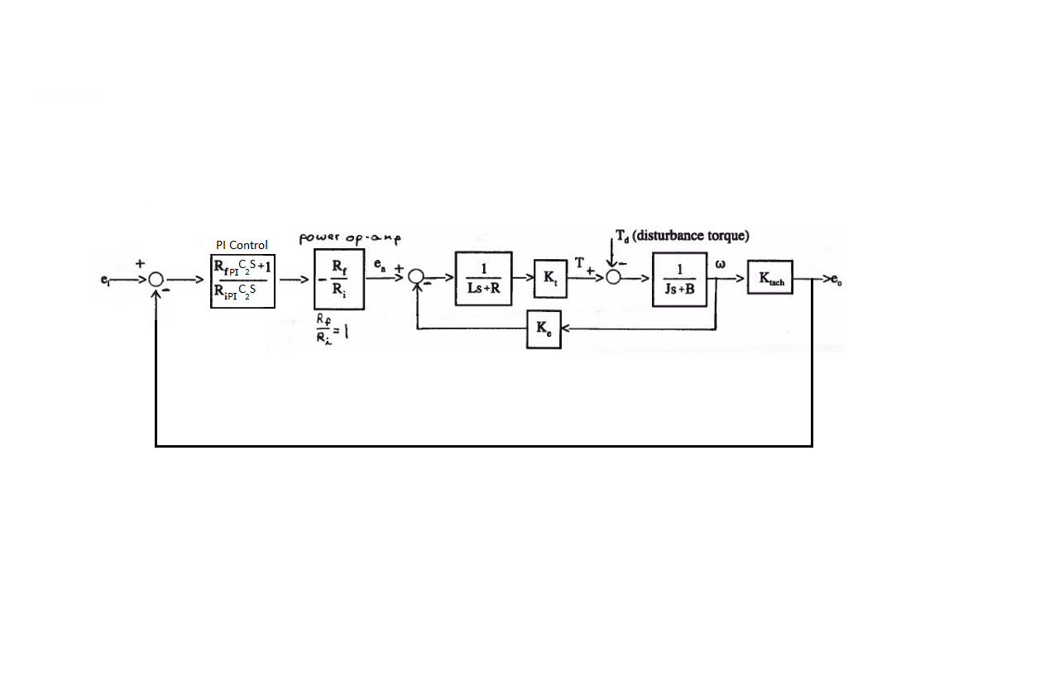

Figure #: PI Controller

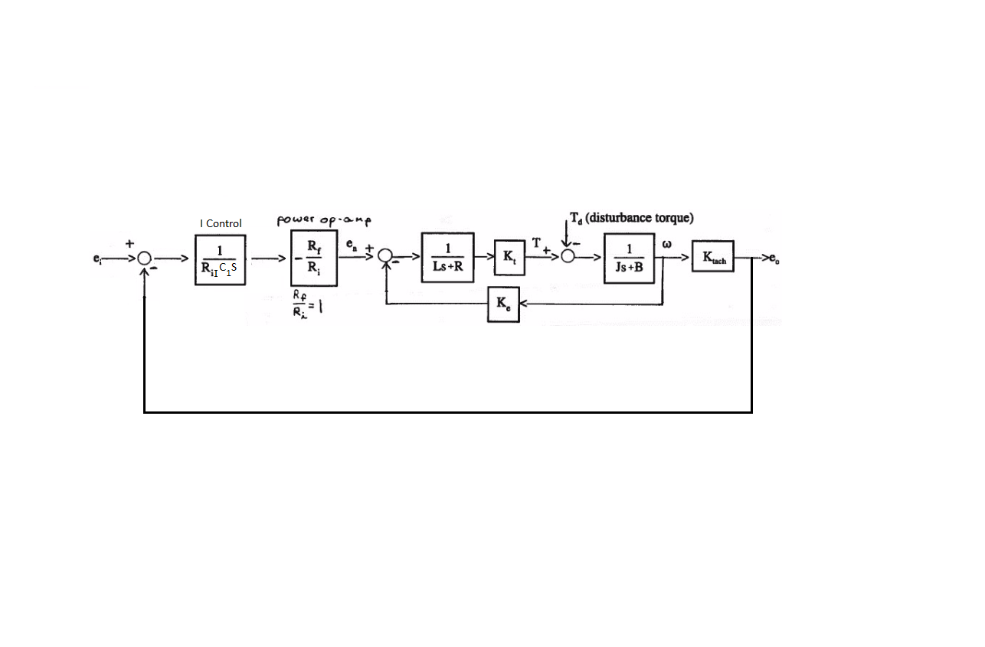

Figure #: I Controller

**Root-locus Plots**

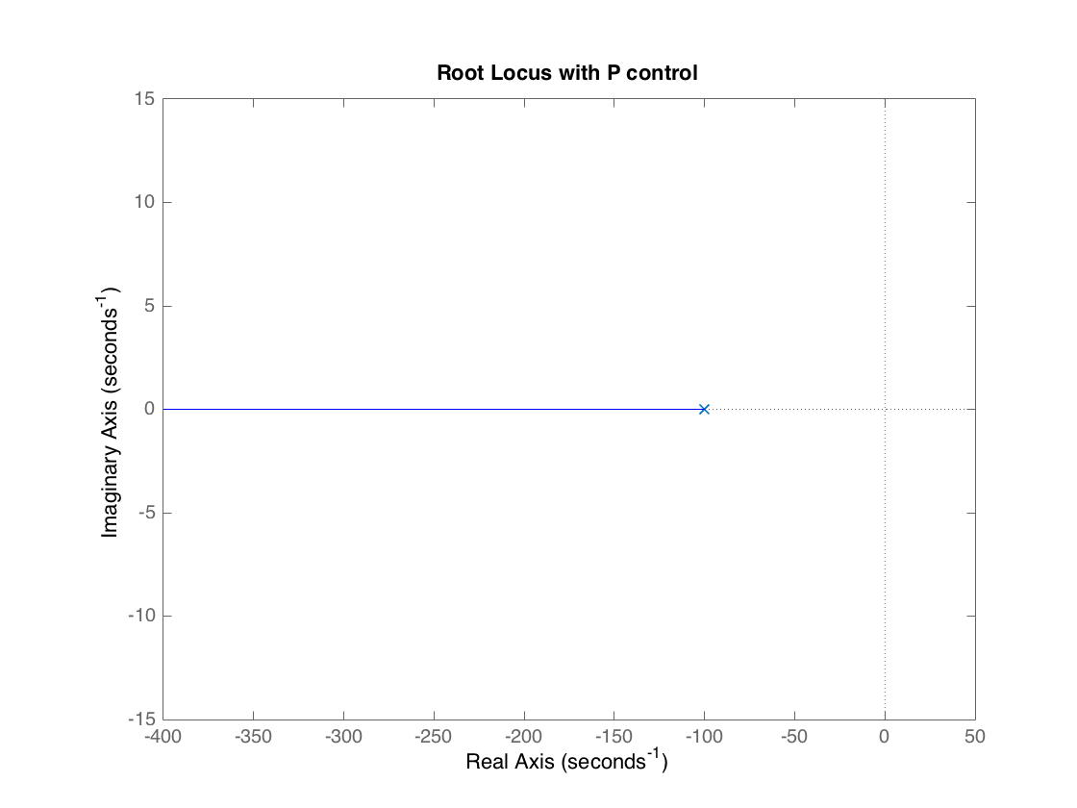

Figure #: P Root Locus

Assuming an additional gain term of 1, the initial pole starts at -100 and continues along the real axis towards negative infinity. The root in **figure #** was found to be .

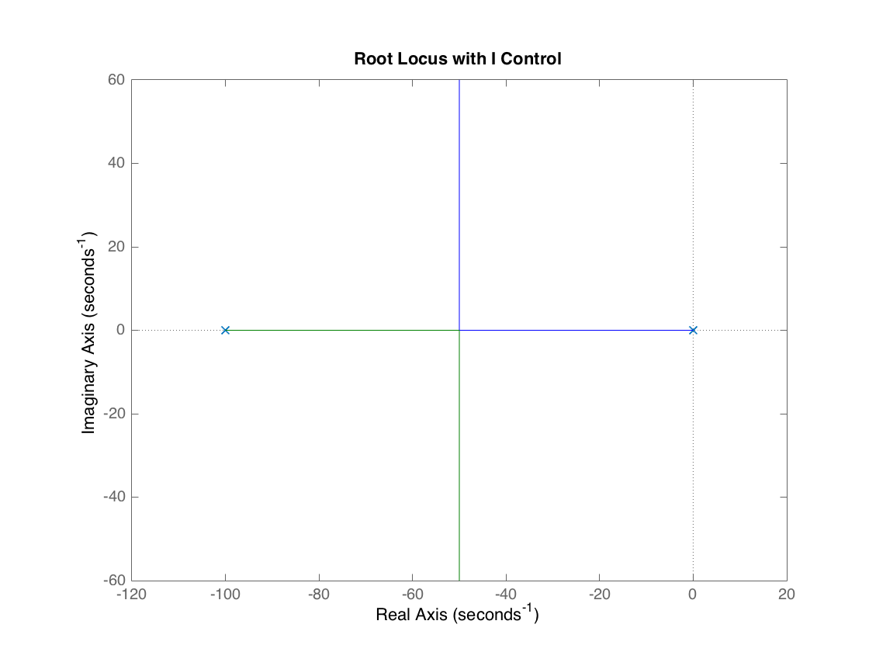

Figure #: I Root Locus

Assuming an additional gain term of 1, the initial poles start at -100 and 0 and they both move toward the asymptote at -50. The roots in **figure #** were found to be .

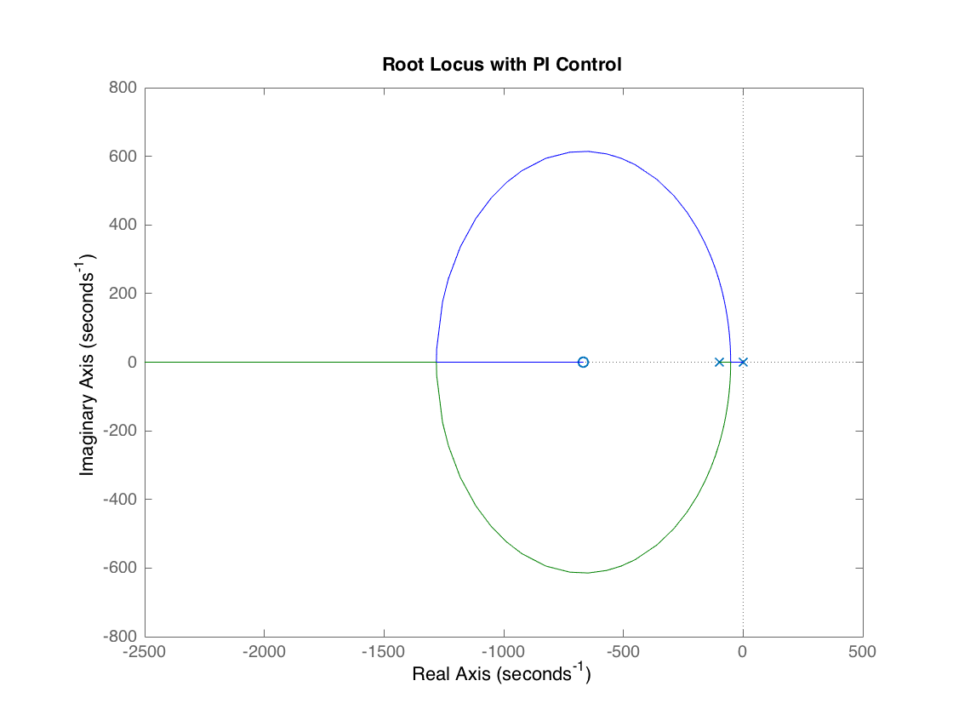

Figure #: PI Root Locus

Assuming an additional gain term of 1, a zero occurs around -677 and extends to negative infinity. The poles start at -100 and 0. The roots in **figure #** were found to be .

**Step Response**

**Figure #** demonstrates the step response for an input voltage step change of -4 V to +4 V. The steady state prediction is slightly higher than the experimental data. This could be explained by unaccounted for friction in the motor. It is also important to note that the steady state output for the P controller is around 2 V instead of 4 V

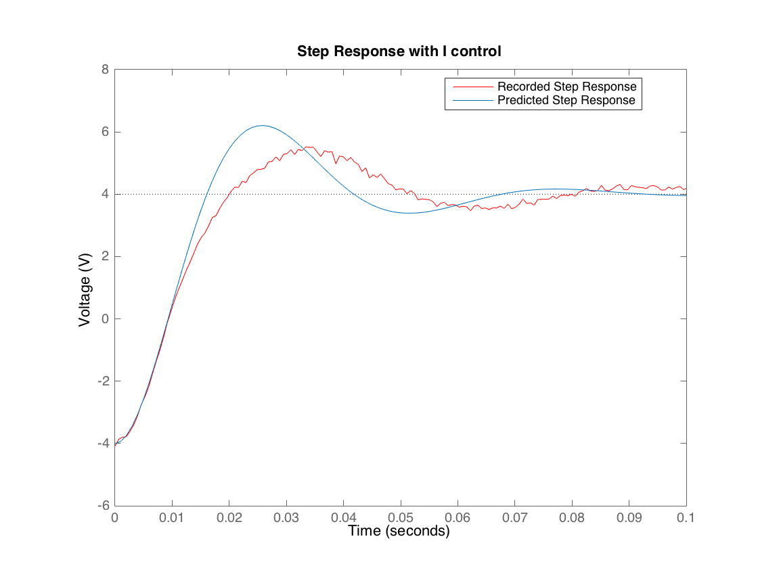

Figure #: I Step Response

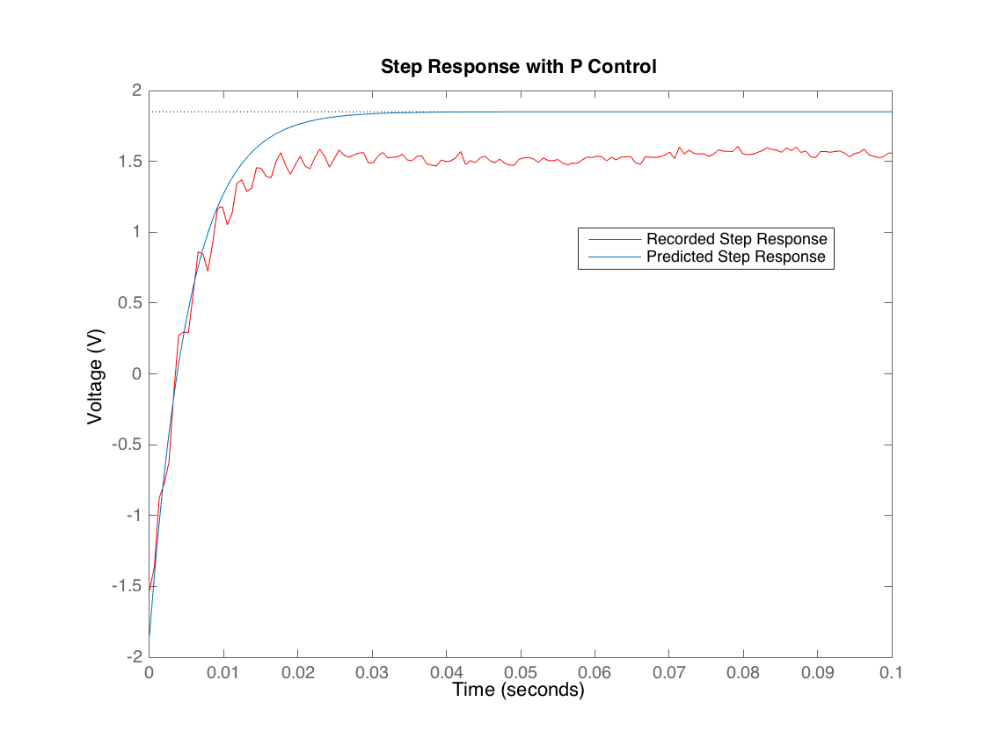

Figure #: P Step Response

**Figure #** shows that the I controller results in a 2nd order output. The experimental data for the I controller is a little slower than the predicted response. It also has higher damping, which can be explained by unaccounted for friction. Unlike the P controller, it reaches the steady state value of 4 V.

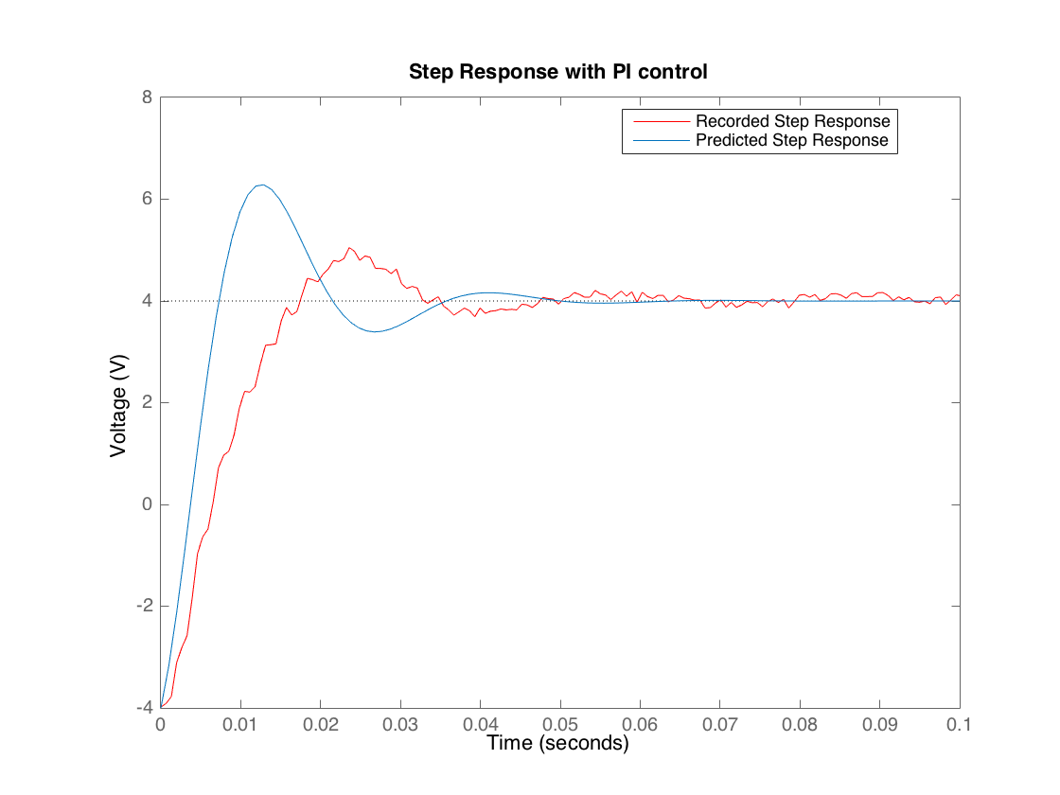

Figure #: I Step Response

The PI predicted results drift even further from the experimental, as seen in **Figure #.** PI also outputs a 2nd order system that reaches a stead state of 4 V.

**Speed of Step Responses and Steady State Error with a Disturbance**

Table 1 Controller Time Constants

|  |  |
| --- | --- |
| Controller | Tao [ms] |
| Open Loop | 10 |
| P | 5.4 |
| I | 20 |
| PI | 10.8 |

**Table #** demonstrates that the P controller has the fastest response time, followed by Open Loop, PI, then I. Again, although P control is the fastest, it cuts the output voltage in half.

Table 2: Controller Steady State Error

|  |  |
| --- | --- |
| Controller | Steady State Error |
| P | .1886 |
| I | .07 |
| PI | 7.38e-4 |

The P controller has the largest error, and I has about half the error as P. PI has significantly less error than either P or I when subjected to a disturbance. This makes PI a desirable controller even though P has a quicker response time.

The primary factor for the difference between the theoretical and experimental results is friction that is unaccounted for in the transfer function.

Error can result from friction within the motors as well as wear to the structure from behaviors such as creep and fatigue. The controller that is chosen should be able to handle the expected error from disturbances over the lifetime of the design.